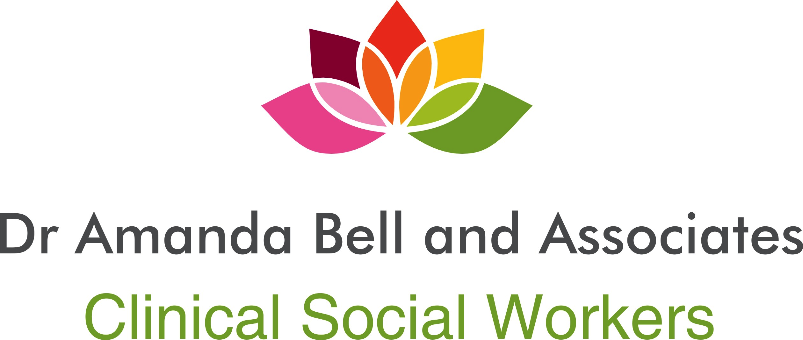
370 Queens Ave, Suite 100

London ON N6B 1X7

Phone: (519) 936-0108 Fax: (519) 936-1028

Consent to Treatment:

I, voluntarily, agree to my receiving mental health services, assessment, care or treatment, and authorize the undersigned therapist to provide such care, treatment or services as are considered necessary and advisable. I understand and agree that I will participate in the planning of my treatment or services, and that I may stop such treatment or services that I receive through the undersigned therapist at any time.

By signing this Consent form, I, the undersigned acknowledge that I have both read and understood all the terms and information contained in the Client and Information Consent and may request a copy of such. Ample opportunity has been offered to me to ask questions and seek clarification of anything unclear to me.

__________________________________________ ____________________________
Client’s Signature Date

____________________________________________
Print Name

____________________________________________ _____________________________
Therapist Signature Date

